

**Step 1.** Create database in hive

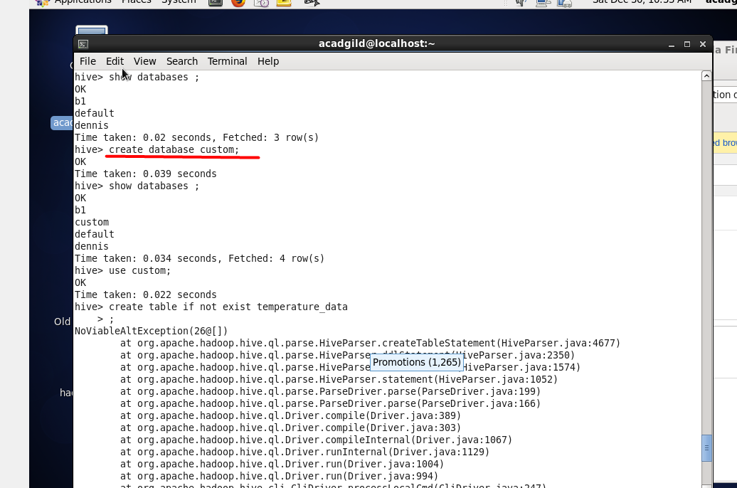

**Step 2.** Create table

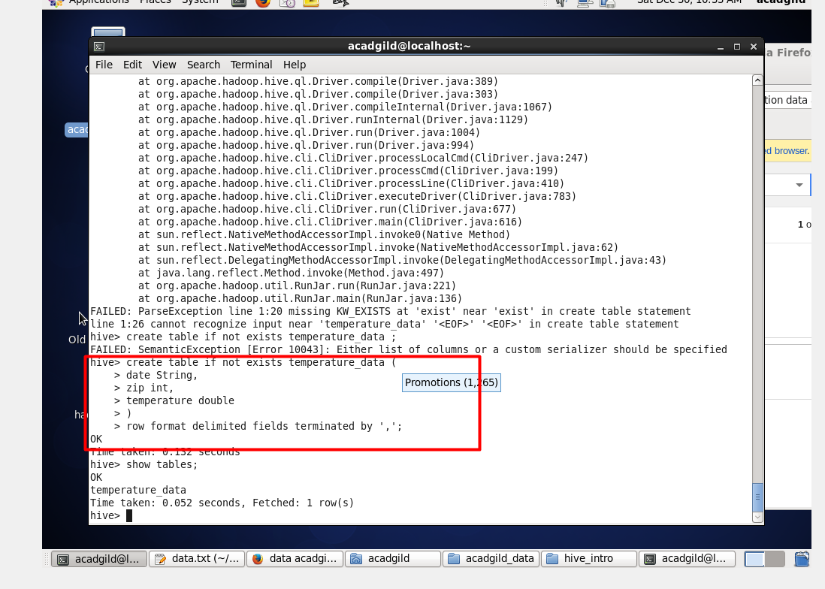

**Step 3.** Load data and check that data loading was done successfully.

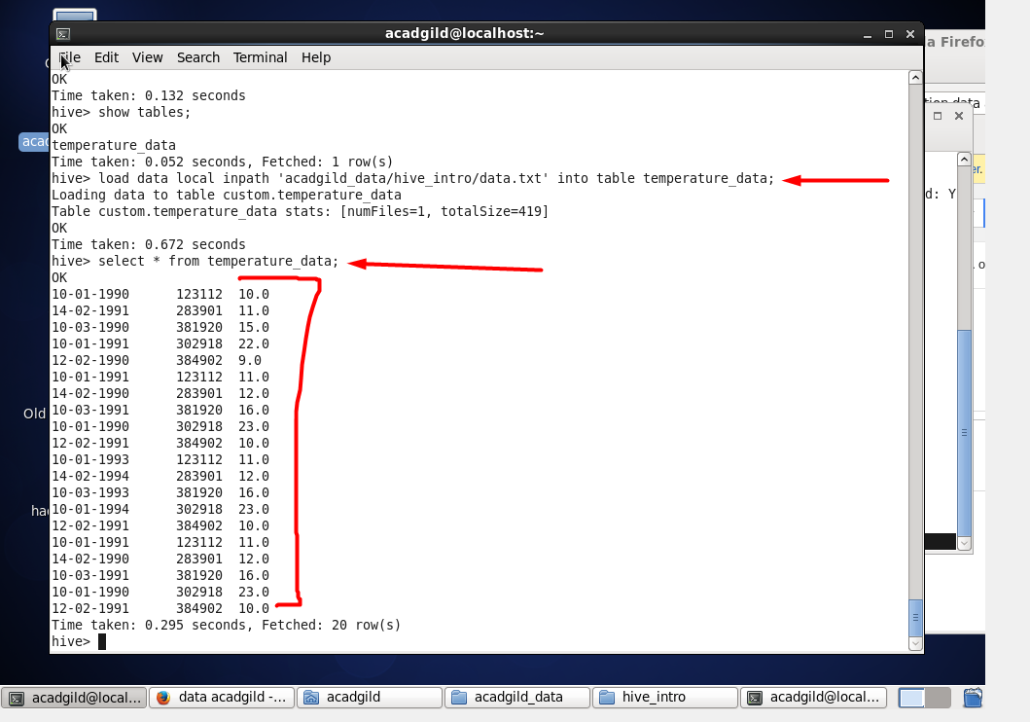

**Step 4.** Double check - try another query.

